Dear Friends,
On Saturday July 15th, 2017 we are inviting you to join us to benefit our Officer that was injured in the line of duty of February 7th, 2017 Brian Arterburn. We are here to raise money for Officer Brian’s recovery. Officer Brian has a long road ahead and as most of you know he is getting stronger everyday and recovering well thanks to everyone’s support and prayers.
The day’s Events will begin at 8:00 am with check-in and registration. Tee Time begins at 9:30 AM with a shot gun start. Lunch will be provided. After lunch we will be awarding prizes to our winners! There will be longest drive awards, longest putt awards, and Closest to the pin awards. We will be announcing 1st, 2nd, 3rd and last place awards in the club house after lunch as well. Don’t miss out on your chance to participate in a great day of golf, support Officer Brian and win fabulous prizes!
Sponsorship opportunities are also available. If you are interested in helping to sponsor the event please contact Gene Vitarelli at 316.807.6330. Donations for prizes are welcome.
We appreciate your participation and any additional contribution you can add to this important event. We look forward to seeing you there!
~ The Arterburn Family

SCHEDULE OF EVENTS
8:00AM
Registration
9:30 AM
Tee Time
12:30 PM
Lunch
1:30 PM
Prizes & Awards
Individual Registration: $ 100.00
Team Registration: $400.00
Includes: Cart, Green Fees, Lunch & Practice Balls
Or be a Sponsor…..
Sponsorship Levels:
Friend Sponsor $ 50.00
Prize Sponsor $100.00
Hole Sponsor $ 200.00
Event Sponsor $ 500.00
REGISTRATION FORM Team Information Player1: Player2: Player3: Player4: Contact information: REQUIRED Address:
State, City, Zip (Suite #):
Email Address or Phone Number:
Sponsorship & Donation DEADLINE DATE FOR SPONSORS: July 10th, 2017 please one: Friend – $50 Prize - $100 Hole - $ 200 Event - $500 Method of Payment Check please make checks to “Sierra Hills golf club” Terms: Mail prior to tournament day or pay day of. Invoice Terms: payment due on or before tournament date Cash Terms: ONLY accepted day of tournament CC Terms: ONLY accepted day of tournament Please Remit form back to: Sierra Hills Golf Club PO Box 780402. Wichita. KS 67278 Contact Name: Andrea Bramhall Email: andrea@cherrywood.kscoxmail.com
GRAND TOTAL $ Donation Receipt? YES NO
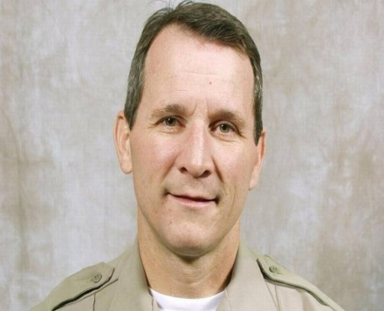

Father, hold us in your caring arms.
Embrace us with your life-giving love.
Apply your resurrecting hands to our
Wounded places. It is your power that
Heals, it is your will that we live in good
Health as our souls seek you. Now, in our
Time of need, deliver us from our
afflictions. ~ AMEN

Thank you for your support and prayers!

